**COA MINI PROJECT C-13**

**NAME:** HARSH HARWANI-51, JENIL JAIN-55, VEDANT JASANI-59

**TITLE:** MULTIPLEXER USING SIMULATOR

**DESCRIPTION:**

**1.What is a Multiplexer?**

The multiplexer or MUX is a digital switch, also called as data selector. It is a combinational circuit with more than one input line, one output line and more than one select line. It allows the binary information from several input lines or sources and depending on the set of select lines, particular input line, is routed onto a single output line.

The basic idea of multiplexing is shown in figure below in which data from several sources are routed to the single output line when the enable switch is ON. That is how the multiplexers are also called as ‘many to one’ combinational circuits.

[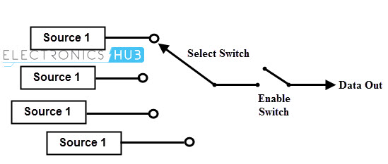](https://www.electronicshub.org/wp-content/uploads/2015/07/What-is-multiplexer.jpg)

The below figure shows the block diagram of a multiplexer consisting of n input lines, m selection lines and one output line. If there are m selection lines, then the number of possible input lines is 2m. Alternatively we can say that if the number of input lines is equal to 2m, then m selection lines are required to select one of n (consider 2m = n) input lines.

This type of multiplexer is referred to as 2n × 1 multiplexer or 2n -to-1 multiplexer. For example, if one of the 4 input lines has to be selected, then two select lines are required. Similarly, to select one of 8 input lines, three select lines are required.

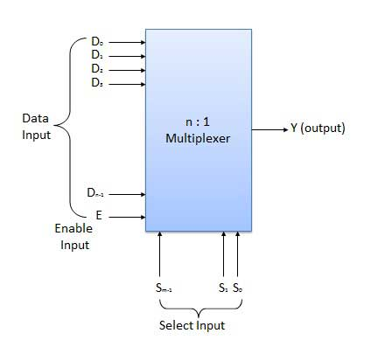

**2.Types of Multiplexers:**

**A] 2:1 Multiplexer:**

A 2-to-1 multiplexer consists of two inputs D0 and D1, one select input S and one output Y. Depends on the select signal, the output is connected to either of the inputs. Since there are two input signals only two ways are possible to connect the inputs to the outputs, so one select is needed to do these operations.

If the select line is low, then the output will be switched to D0 input, whereas if select line is high, then the output will be switched to D1 input. The figure below shows the block diagram of a 2-to-1 multiplexer which connects two 1-bit inputs to a common destination.

[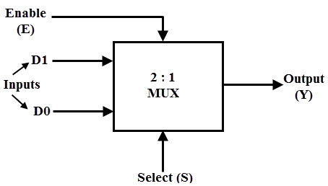](https://www.electronicshub.org/wp-content/uploads/2015/07/2-to-1-MUX.jpg)

The truth table of the 2-to-1 multiplexer is shown below. Depending on the selector switching the inputs are produced at outputs , i.e., D0 , D1 and are switched to the output for S=0 and S=1 respectively . Thus, the Boolean expression for the output becomes D0 when S=0 and output is D1 when S=1.

From the truth table the Boolean expression of the output is given as

[exp](https://www.electronicshub.org/wp-content/uploads/2015/07/exp6.jpg)

[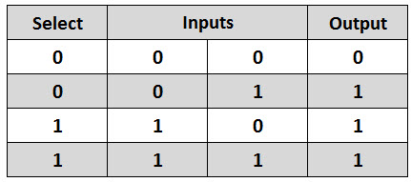](https://www.electronicshub.org/wp-content/uploads/2015/07/2-to-1-MUX-truth-table.jpg)

From the above output expression, the logic circuit of 2-to-1 multiplexer can be implemented using logic gates as shown in figure. It consists of two AND gates, one NOT gate and one OR gate. When the select line, S=0, the output of the upper AND gate is zero, but the lower AND gate is D0.

Thus, the output generated by the OR gate is equal to D0. Similarly, when S=1, the output of the lower AND gate is zero, but the output of upper AND gate is D1. Therefore, the output of the OR gate is D1. Thus, the above given Boolean expression is satisfied by this circuit.

[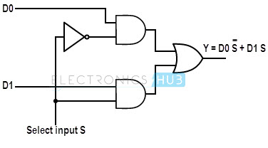](https://www.electronicshub.org/wp-content/uploads/2015/07/2-to-1-mux-logic-diagram.jpg)

In some cases, two or more multiplexers are fabricated on a single IC because simple logic gates can implement the multiplexer. Generally four 2 line to 1 line multiplexers are fabricated in a single IC as shown in figure below. Some of these ICs of 2 to 1 multiplexers include IC 74157 and IC 74158. The selection line controls the input lines to the output in all four multiplexers.

The output Y1 can be selected such that its value may be equal to A1 or B1, Y2 can be either A2 or B2 and so on. The control input E enables and disables all the multiplexers, i.e., when E=1, outputs of all the multiplexer is zero irrespective of the value of S

[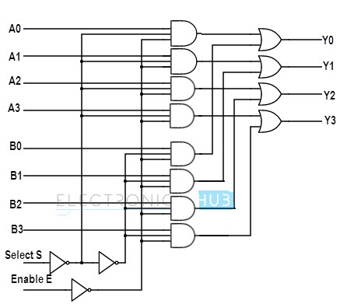](https://www.electronicshub.org/wp-content/uploads/2015/07/Quadruple-2-to-1-multiplier.jpg)

### B] 4:1 Multiplexer:

A 4-to-1 multiplexer consists four data input lines as D0 to D3, two select lines as S0 and S1 and a single output line Y. The select lines S1 and S2 select one of the four input lines to connect the output line. The particular input combination on select lines selects one of input (D0 through D3) to the output.

The figure below shows the block diagram of a 4-to-1 multiplexer in which the multiplexer decodes the input through select line.

[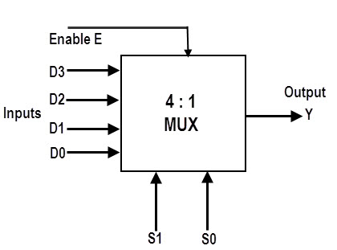](https://www.electronicshub.org/wp-content/uploads/2015/07/4-to-1-MUX.jpg)

The truth table of a 4-to-1 multiplexer is shown below in which four input combinations 00, 10, 01 and 11 on the select lines respectively switches the inputs D0, D2, D1 and D3 to the output. That means when S1=0 and S0 =0, the output at Y is D0, similarly Y is D1 if the select inputs S1=0 and S0= 1 and so on.

[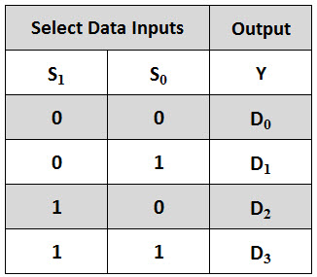](https://www.electronicshub.org/wp-content/uploads/2015/07/4-to-1-MUX-Truth-Table.jpg)

From the above truth table, we can write the output expressions as

If S1=0 and S0=0 then Y = D0

Therefore, Y = D0 (S1) ̅ (S0) ̅

If S1= 0 and S0=1, the Y = D1

Therefore, Y = D1 (S1) ̅ S0

If S1=1 and S0=0, then Y = D2

Therefore, Y = D2 S1 (S0) ̅

If S1=1 and S0=1 the Y = D3

Therefore, Y = D3 S1 S0

To get the total data output from the multiplexer, all these product terms are to be summed and then the final Boolean expression of this multiplexer is given as

[exp1](https://www.electronicshub.org/wp-content/uploads/2015/07/exp11.jpg)

From the above expression of the output, a 4-to-1 multiplexer can be implemented by using basic logic gates. The below figure shows the logic circuit of 4:1 MUX which is implemented by four 3-inputs AND gates, two 1-input NOT gates, and one 4-inputs OR gate.

In this circuit, each data input line is connected as input to an AND gate and two select lines are connected as other two inputs to it. The AND gate output is connected to with inputs of OR gate so as to produce the output Y.

[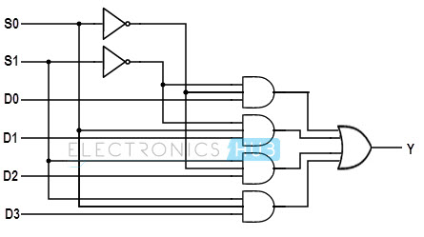](https://www.electronicshub.org/wp-content/uploads/2015/07/4-to-1-MUX-logic-diagram.jpg)

Generally, this type of multiplexers is available in dual IC forms and most common type is IC 74153 which is a dual 4-to-1 line multiplexer. It consists of two identical and independent 4-to-1 multiplexers. It has two separate enable or strobe inputs to switch ON or OFF the multiplexers.

Usually, the enable input or strobe can be used to cascade two or more multiplexer ICs to construct a multiplexer with large number of inputs. Each multiplier is supplied with separate inputs. The figure below shows the pin diagram of IC74153.

[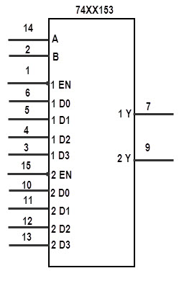](https://www.electronicshub.org/wp-content/uploads/2015/07/Logic-symbol-of-74153.jpg)

### C] 8:1 Multiplexer:

An 8-to-1 multiplexer consists of eight data inputs D0 through D7, three input select lines S2 through S0 and a single output line Y. Depending on the select lines combinations, multiplexer decodes the inputs.

The below figure shows the block diagram of an 8-to-1 multiplexer with enable input that enable or disable the multiplexer. Since the number data bits given to the MUX are eight then 3 bits (23=8) are needed to select one of the eight data bits.

[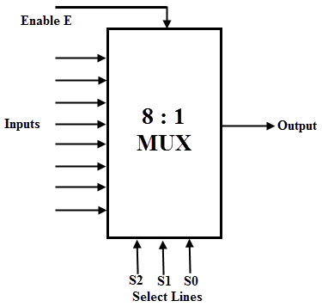](https://www.electronicshub.org/wp-content/uploads/2015/07/8-to-1-MUX.jpg)

The truth table for an 8-to1 multiplexer is given below with eight combinations of inputs so as to generate each output corresponds to input.

For example, if S2= 0, S1=1 and S0=0 then the data output Y is equal to D2. Similarly the data outputs D0 to D7 will be selected through the combinations of S2, S1 and S0 as shown in below figure.

[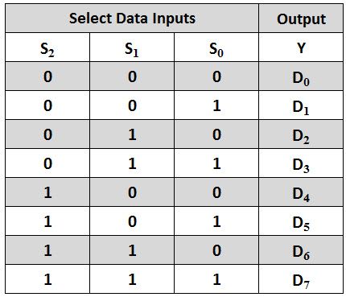](https://www.electronicshub.org/wp-content/uploads/2015/07/8-to-1-MUX-Truth-Table.jpg)

From the above truth table, the Boolean equation for the output is given as

[exp3](https://www.electronicshub.org/wp-content/uploads/2015/07/exp3.bmp)

From the above Boolean equation, the logic circuit diagram of an 8-to-1 multiplexer can be implemented by using 8 AND gates, 1 OR gate and 7 NOT gates as shown in below figure. In the circuit, when enable pin is set to one, the multiplexer will be disabled and if it is zero then select lines will select the corresponding data input to pass through the output.

[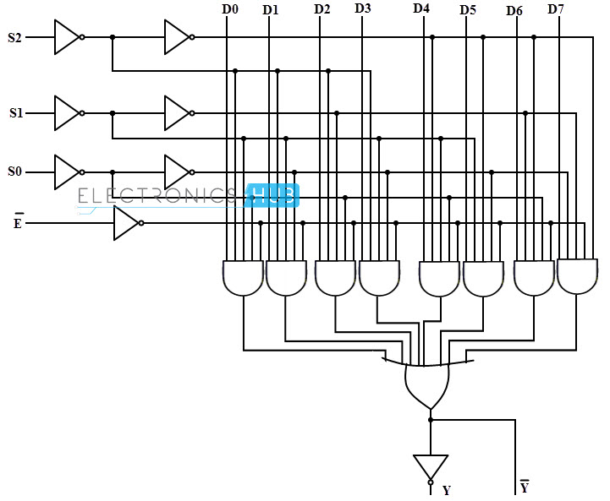](https://www.electronicshub.org/wp-content/uploads/2015/07/8-to-1-MUX-logic-diagram.jpg)

A typical IC 74151 is an 8-to-1 multiplexer with eight inputs and two outputs. The two outputs are active low and active high outputs. It has three select lines A, B and C and one active low enable input. The pinout of this IC is given below.

[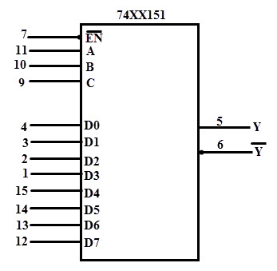](https://www.electronicshub.org/wp-content/uploads/2015/07/74151-IC.jpg)

### 3. Applications of Multiplexer:

In all types of digital system applications, multiplexers find its immense usage. Since these allows multiple inputs to be connected independently to a single output, these are found in variety of applications including data routing, logic function generators, control sequencers, parallel-to-serial converters, etc.